Big Data:
Big data is a combination of unstructured, semi-structured or structured data collected by organizations. These data sets can be mined to gain insights and used in machine learning projects, predictive modelling and other advanced analytics applications.
Big data can be used to improve operations, provide better customer service and create personalized marketing campaigns all of which can increase value for an organization.

4 Vs of Big Data:
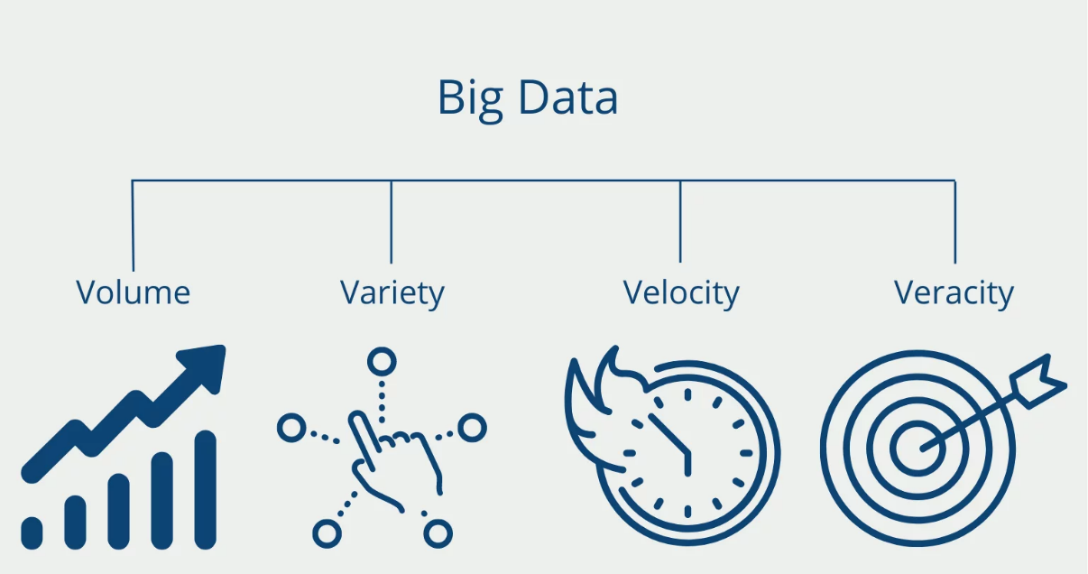

Velocity
Velocity refers to how quickly data is generated and how fast it moves. This is an important aspect for organizations that need their data to flow quickly, so it's available at the right times to make the best business decisions possible.
An organization that uses big data will have a large and continuous flow of data that's being created and sent to its end destination. Data could flow from sources such as machines, networks, smartphones or social media. Velocity applies to the speed at which this information arrives -- for example, how many social media posts per day are ingested -- as well as the speed at which it needs to be digested and analysed.
As an example, in healthcare, many medical devices today are designed to monitor patients and collect data. From in-hospital medical equipment to wearable devices, collected data needs to be sent to its destination and analysed quickly.

Volume
Volume refers to the amount of data that exists. Volume is like the base of big data, as it's the initial size and amount of data that's collected. If the volume of data is large enough, it can be considered big data. However, what's considered to be big data is relative and will change depending on the available computing power that's on the market.
For example, a company that operates hundreds of stores across several states generates millions of transactions per day. This qualifies as big data, and the average number of total transactions per day across stores represents its volume.

Variety
Variety refers to the diversity of data types. An organization might obtain data from several data sources, which might vary in value. Data can come from sources in and outside an enterprise as well. The challenge in variety concerns the standardization and distribution of all data being collected.
Collected data can be unstructured, semi-structured or structured. Unstructured data is data that's unorganized and comes in different files or formats. Typically, unstructured data isn't a good fit for a mainstream relational database because it doesn't fit into conventional data models. Semi-structured data is data that hasn't been organized into a specialized repository but has associated information, such as metadata. This makes it easier to process than unstructured data. Structured data, meanwhile, is data that has been organized into a formatted repository. This means the data is made more addressable for effective data processing and analysis.
Raw data also qualifies as a data type. While raw data can fall into other categories -- structured, semi-structured or unstructured -- it's considered raw if it has received no processing at all. Most often, raw applies to data imported from other organizations or submitted or entered by users. Social media data often falls into this category.
A more specific example could be found in a company that gathers a variety of data about its customers. This can include structured data culled from transactions or unstructured social media posts and call centre text. Much of this might arrive in the form of raw data, requiring cleaning before processing.

Veracity
Veracity refers to the quality, accuracy, integrity and credibility of data. Gathered data could have missing pieces, might be inaccurate or might not be able to provide real, valuable insight. Veracity, overall, refers to the level of trust there is in the collected data.
Data can sometimes become messy and difficult to use. A large amount of data can cause more confusion than insights if it's incomplete. For example, in the medical field, if data about what drugs a patient is taking is incomplete, the patient's life could be endangered.
Both value and veracity help define the quality and insights gathered from data. Thresholds for the truth of data often -- and should -- exist in an organization at the executive level, to determine whether it's suitable for high-level decision-making.
Where might a red flag appear over the veracity data? It could, for instance, be lacking in proper data lineage -- that is, a verifiable trace of its origins and movement.

